Harahan Spring Classic Horseshoe Tournament
April 1, 2017
Waggaman Playground

A Class
1st Place Bill Seither
2nd Place Edie Corso
3rd Place Burnie Williams

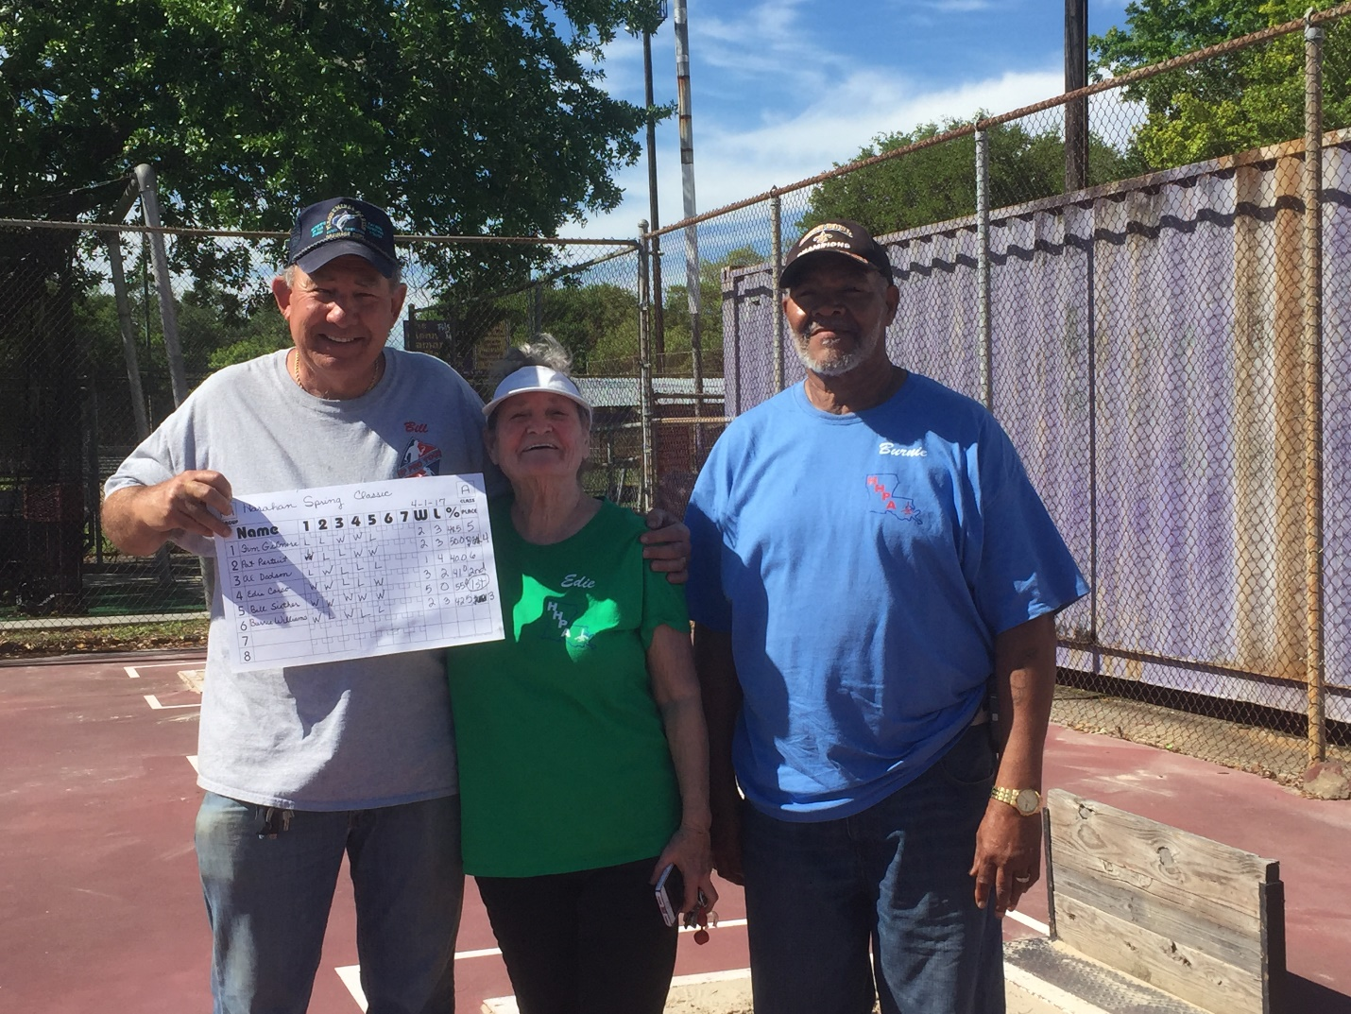

B Class
1st Place Mary Chrismer
2nd Place Glenn Calliouet
3rd Place Wanda Lantz
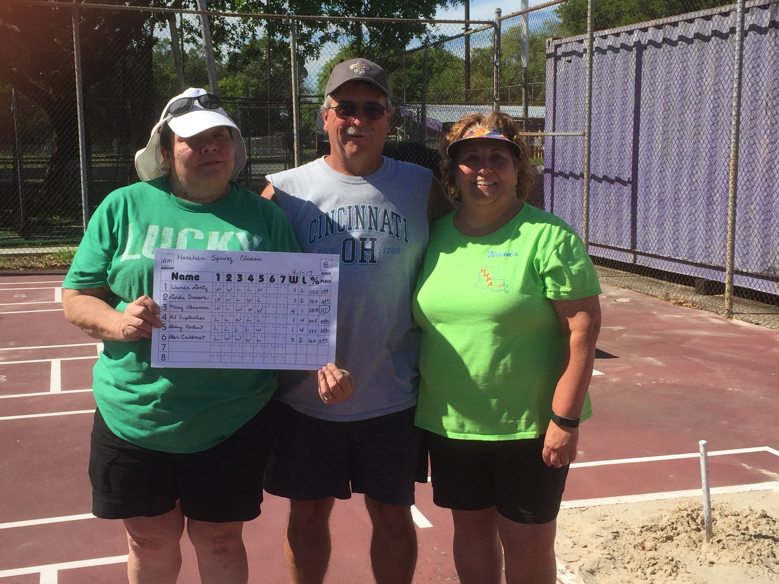

C Class
1st Place Gil Gerard
2nd Place Gary Verheide
3rd Place Greg Comeaux
