Harahan MDA Tournament
May 27, 2017
Waggaman Playground

A Class
1st Place Tim Gilmore
2nd Place Roy Willie
3rd Place Gerald Prados

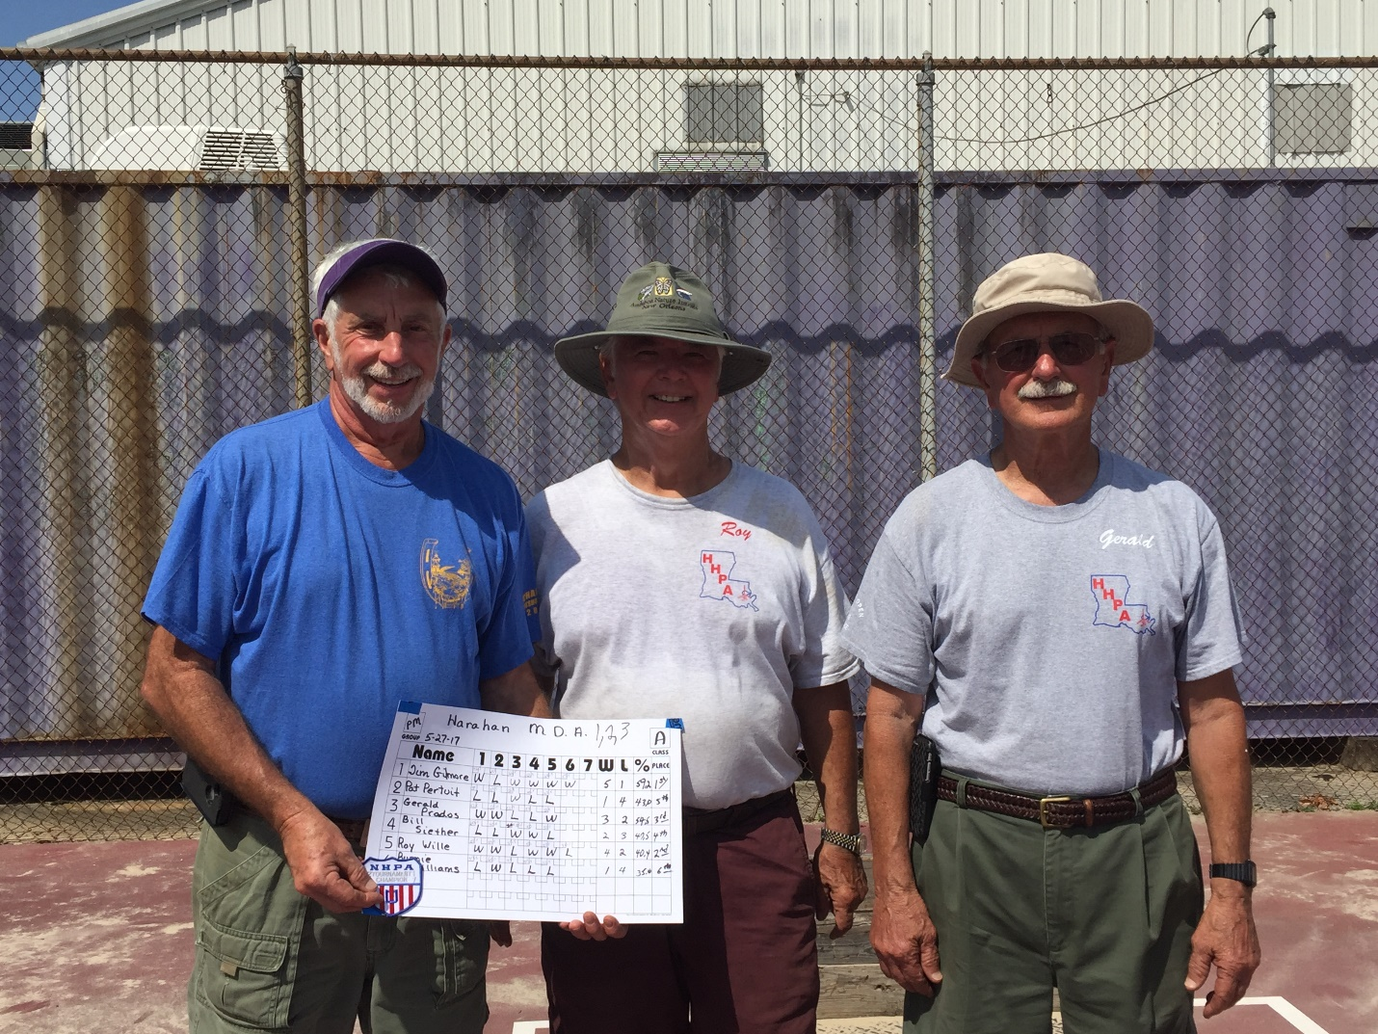

B Class
1st Place Larry Pertuit
2nd Place Cheryl Matt
3rd Place Mary Begnaud
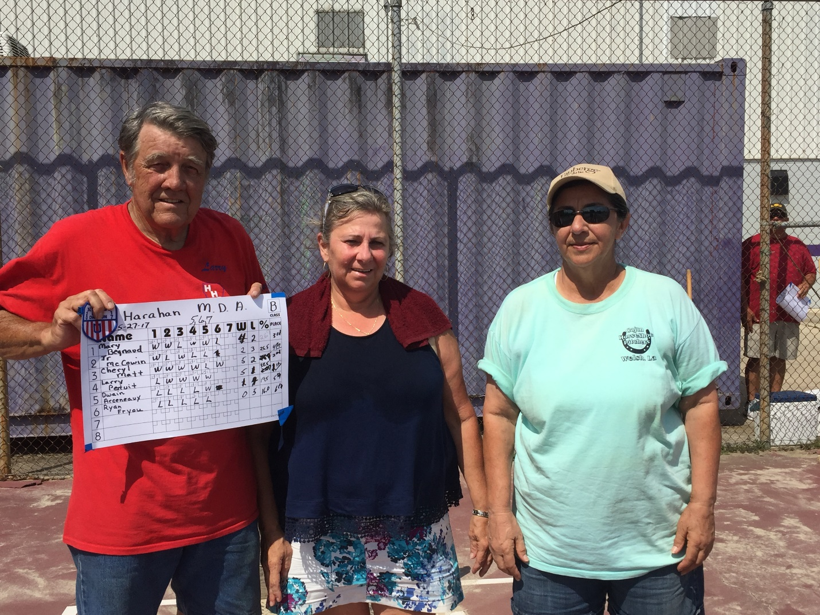

C Class
1st Place Glenn Caillouet
2nd Place Gil Gerard
3rd Place Hilton Rhodes
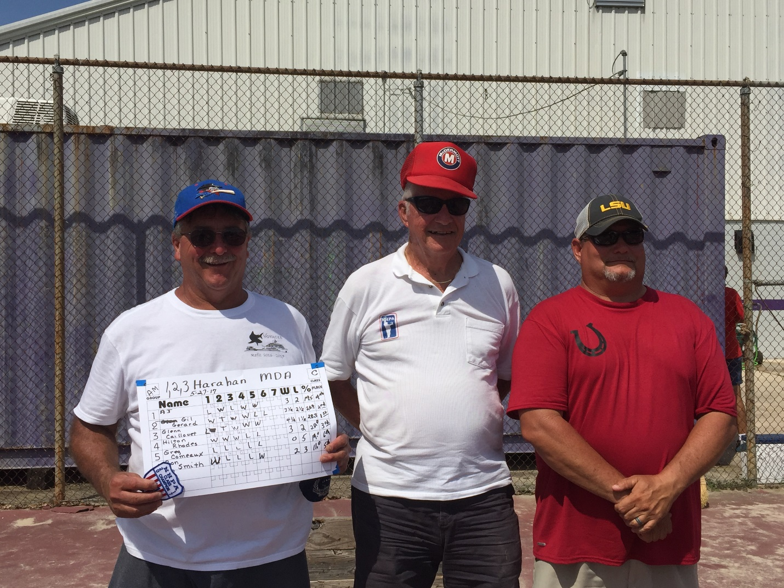

D Class
1st Place David Bourdier
2nd Place Travis Bourdier
3rd Place Mike Fonseca

