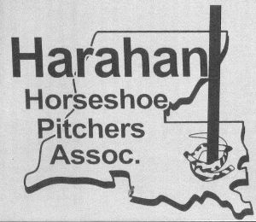
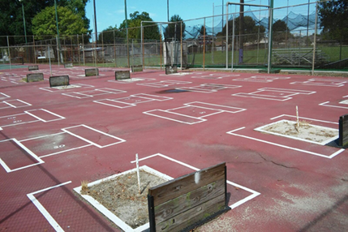

Harahan Open Horseshoe Tournament is this Saturday July 8th .

The tournament has been moved to:

Waggaman Playground
516 Dandelion St
Waggaman, LA 70094

It’s just a hop skip and a jump over the bridge.

The club will sell water, drinks, food and tickets.
You may bring your adult beverages.

Start time will be 9:00 am.

Cost is $20.00 a person.
Please notify Mary at chrismer.mj@yahoo.com or 504-737-6712, Roy Willie at rwille144@cox.net or 504-738-9072, or Larry Pertuit at 504-715-0184 if you are interested in playing before Thursday evening July 6th.

